Lab-5

Sorting & Filtering

1.Filtering using BETWEEN

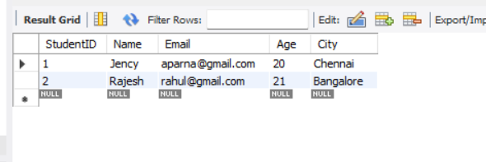

2.Removing duplicate values

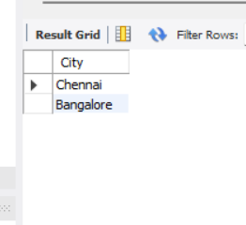

3.Filtering using IN

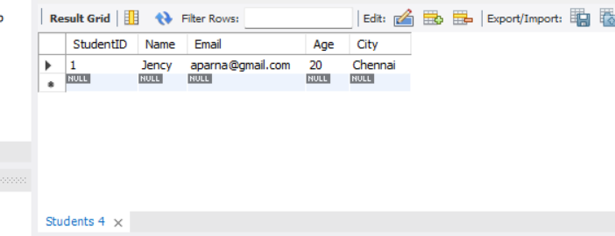

4.Sorting records

